github

Email- [ramesh.dongre99@gmail.com](mailto:ramesh.dongre99@gmail.com)

Password- Corp#123

Username- ramesh2909

Jenkins

User –admin12

Password – admin\*123

Jenkins initial admin password-

0e2c20e4900c4fb4a0affc3d1b30c647

<http://localhost:8080/>

git hub project url-

https://github.com/ramesh2909/nopcommerceApp.git

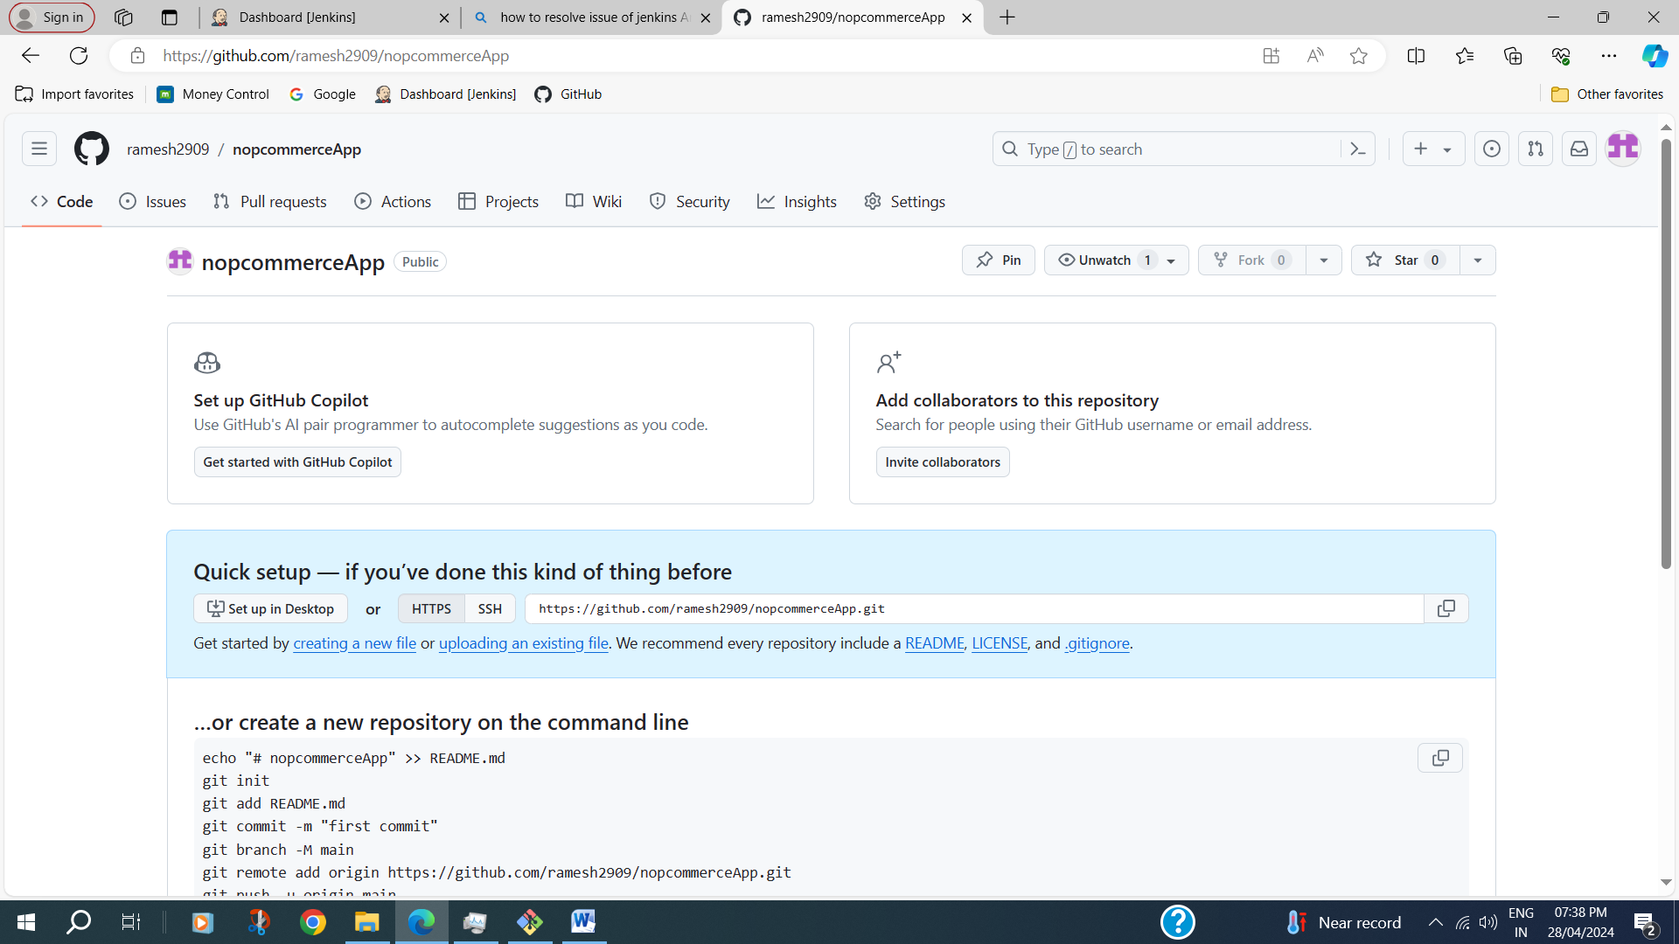

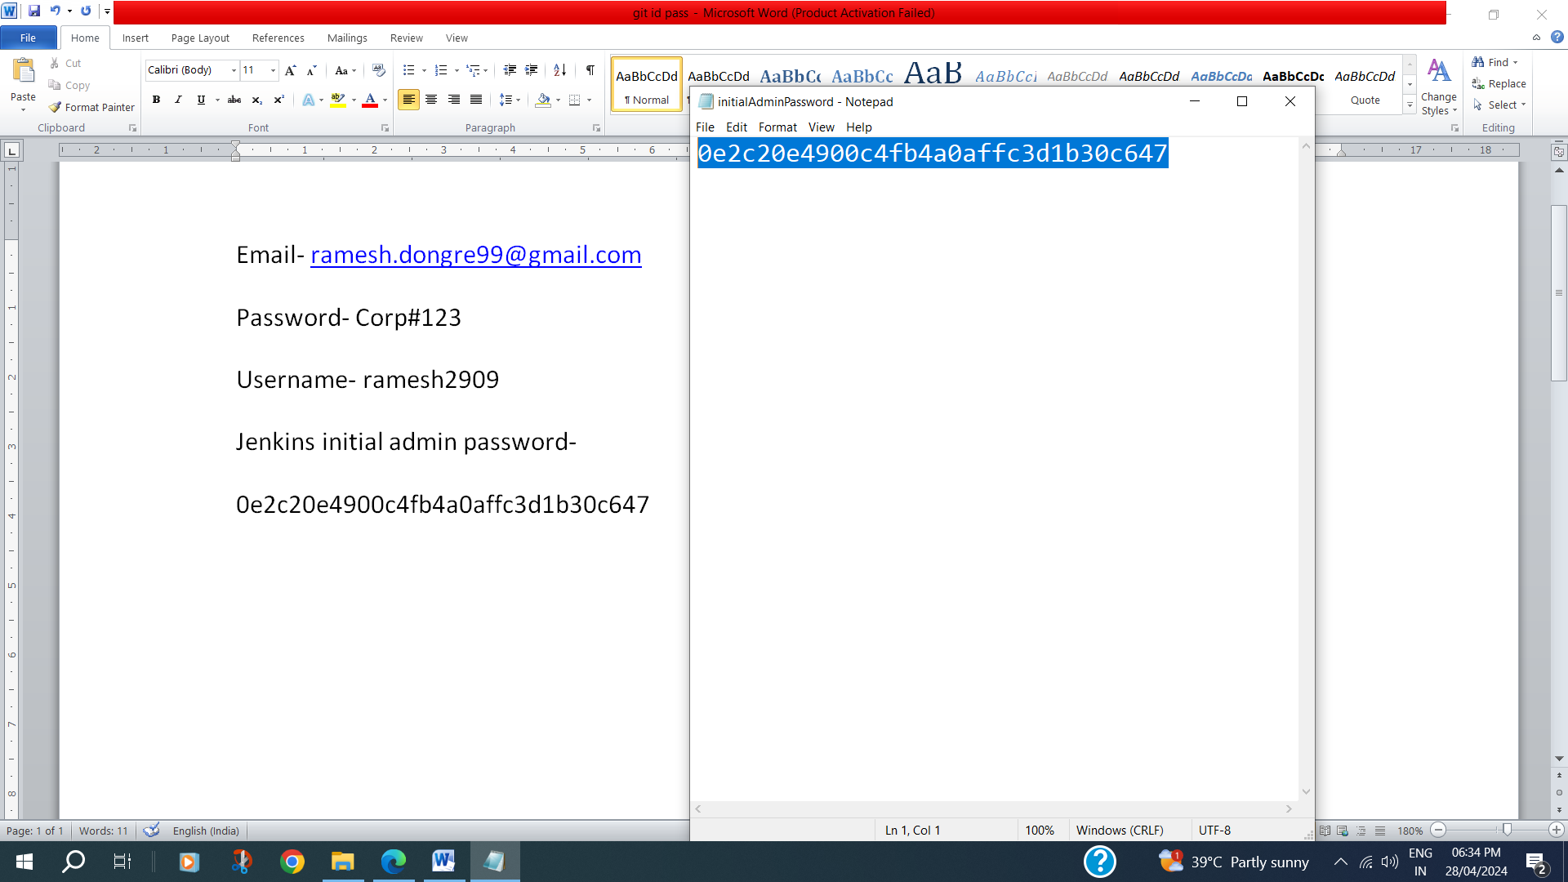

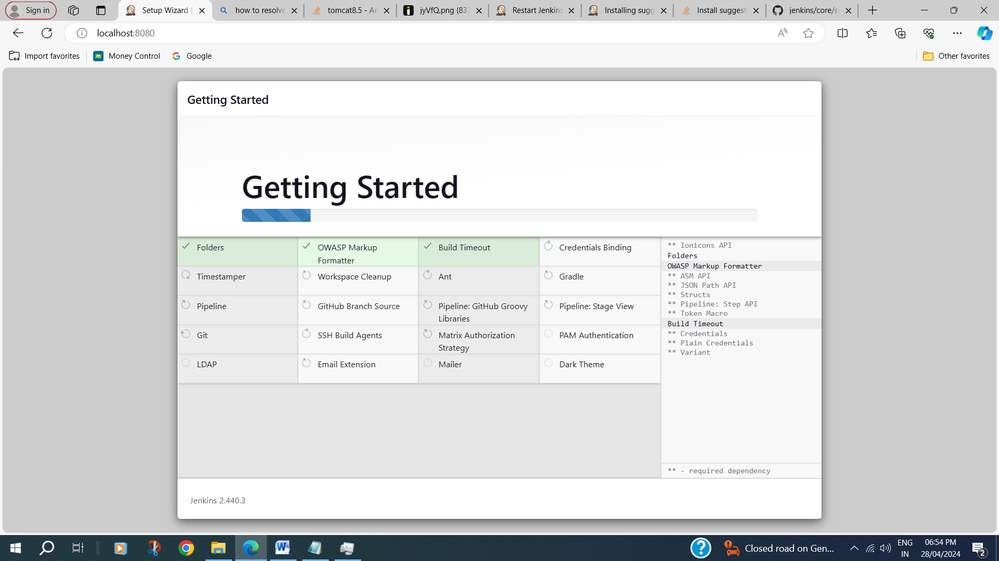

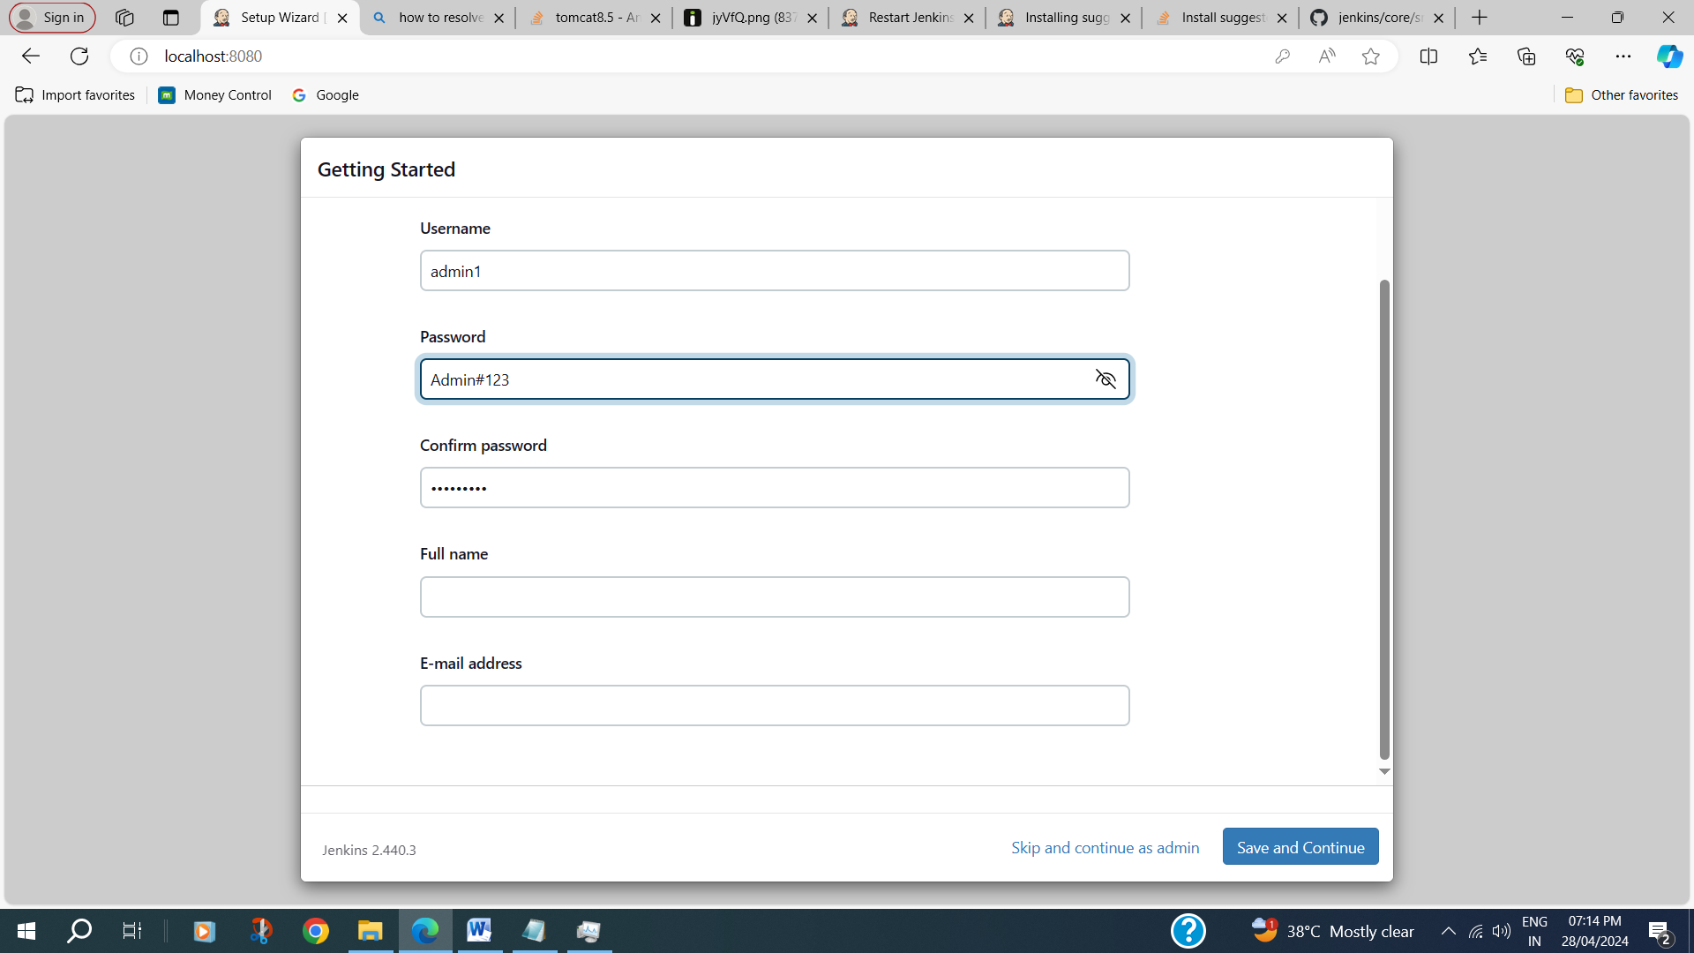

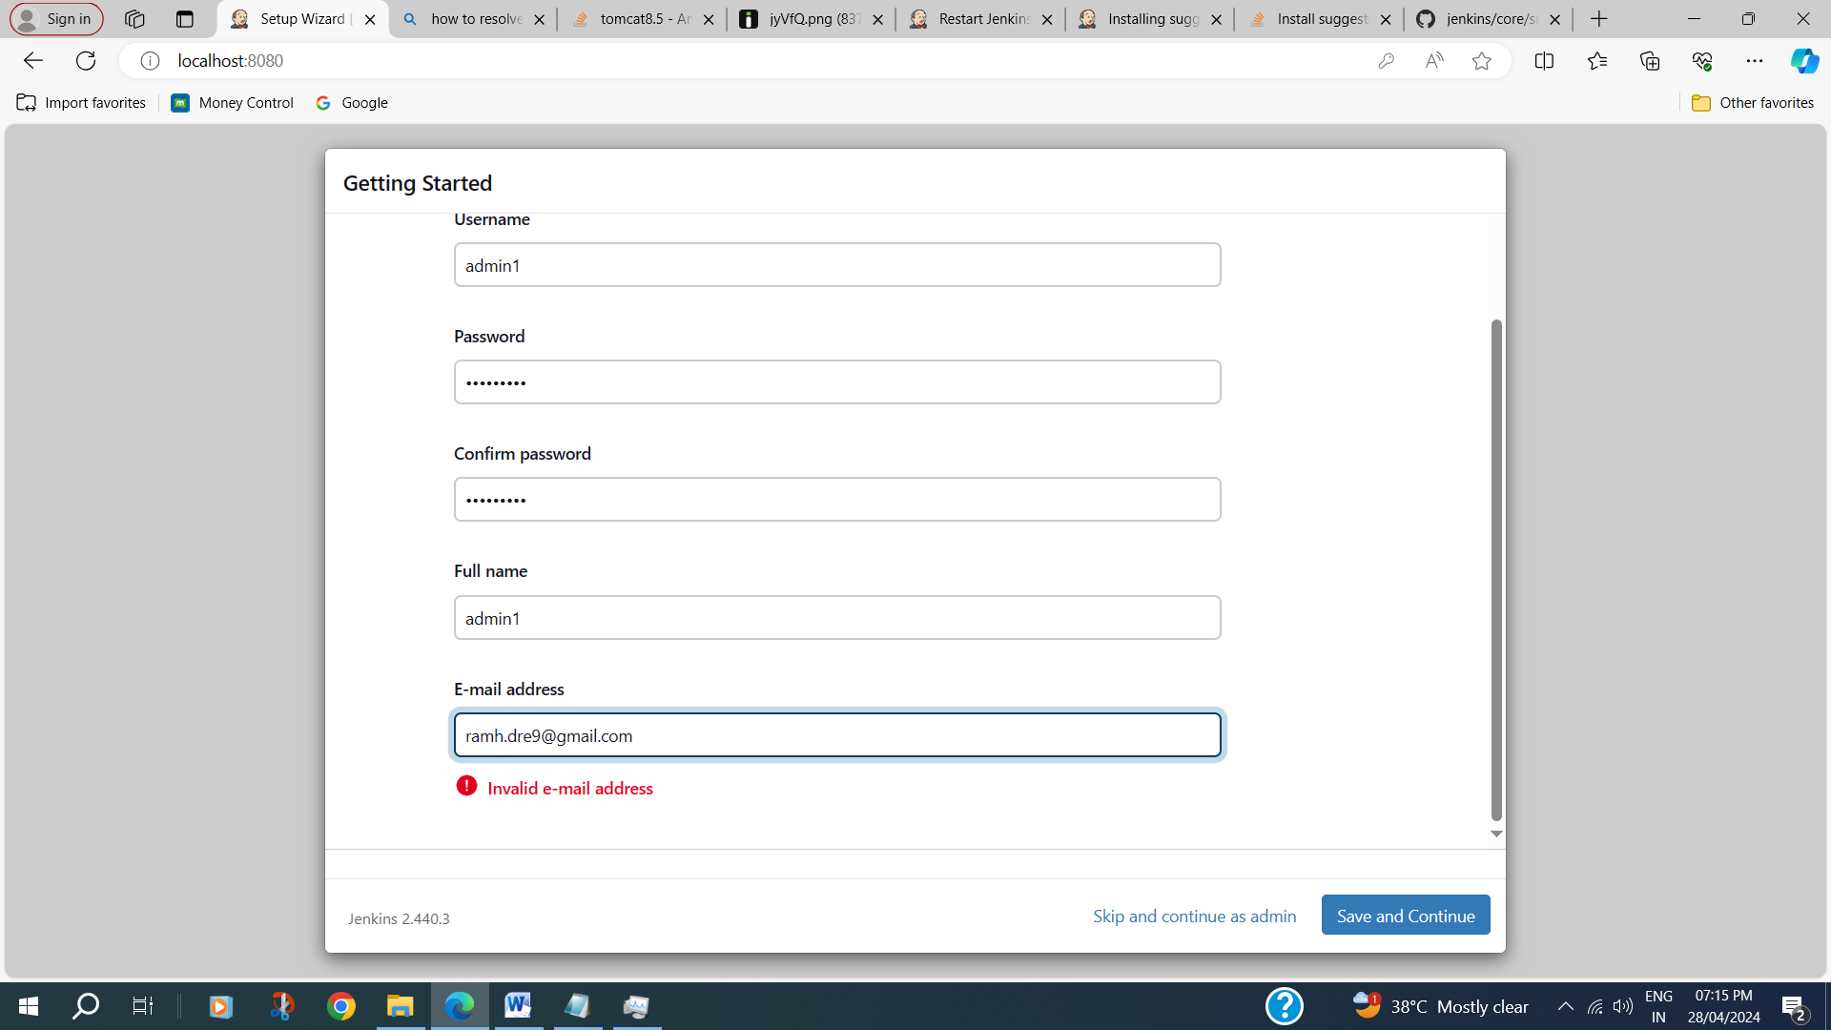

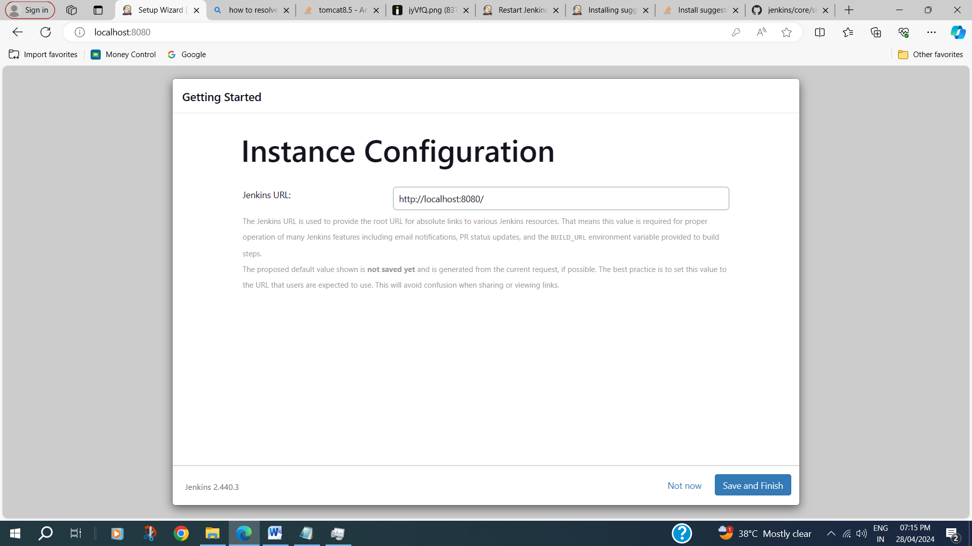

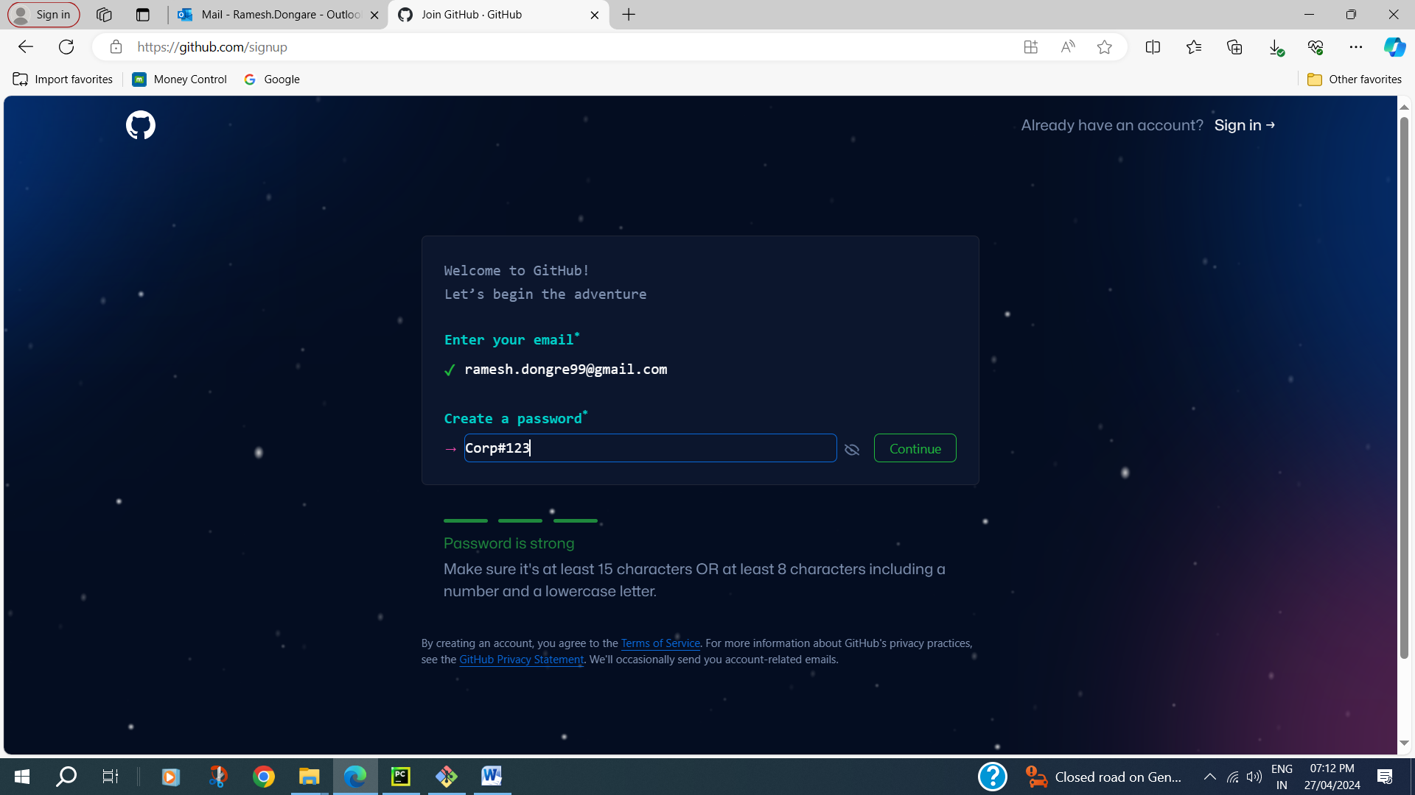

Jenkins war file

